from The Girl Who Changed Pakistan: Malala Yousafzai by Shehrbano Taseer | October 22, 2012
The teenage girls chatted to each other and their teachers as the school bus rattled along the country road. Students from a girls’ high school in Swat, they had just finished a term paper, and their joy was evident as they broke into another Pashto song. About a mile outside the city of Mingora, two men flagged down and boarded the bus, one of them pulling out a gun. “Which one of you is Malala Yousafzai?” he demanded. No one spoke—some out of loyalty, others out of fear. But, unconsciously, their eyes turned to Malala. “That’s the one,” the gunman said, looking the 15-year-old girl in the face and pulling the trigger twice, shooting her in the head and neck. He fired twice more, wounding two other girls, and then both men fled the scene.
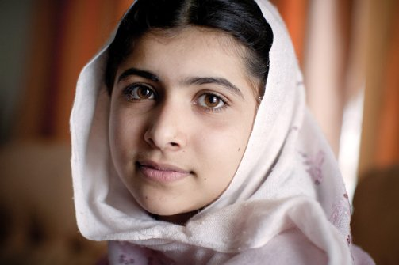
Malala in 2009 (Veronique de Viguerie / Getty Images)

Over the screams and tears of the girls, a teacher instructed the bus driver to drive to a local hospital a few miles away. She stared in horror at Malala’s body, bleeding profusely and slumped unconscious in her friend’s lap, then closed her eyes and started to pray.
As of this writing, Malala fights for her life at the Queen Elizabeth Hospital in Birmingham, England. Her would-be killers have not yet been caught. But it’s clear who bears responsibility. And in the days since the Oct. 9 assault on her, sadness, fury, and indignation have swept the world.
For months a team of Taliban sharpshooters studied the daily route that Malala took to school, and, once the attack was done, the Tehrik-e-Taliban in Pakistan gleefully claimed responsibility, saying Malala was an American spy who idolized the “black devil Obama.” She had spoken against the Taliban, they falsely said, and vowed to shoot her again, should she survive.
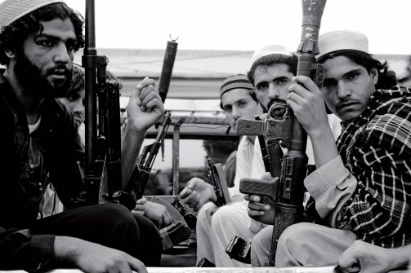
These clerics are raising merchants of hatred, believers in radical Islam. (Lynsey Addario / VII)

The power of ignorance is frightening. …
What the attack on Malala makes clear is that this is really a battle over education. A repressive mindset has been allowed to flourish in Pakistan because of the madrassa system set up by power-hungry clerics. It’s a deeply rooted indoctrination, and it sickens me to see ancient religious traditions undermined by a harsher form of religion barely a generation old. These madrassa, or religious schools headed by clerics, are the breeding ground of Islamic radicalism. The clerics don’t teach critical thinking. Instead, they disseminate hate. These clerics are raising merchants of hatred who believe in a very right-wing and radical Islam, to hail people like Osama bin Laden and Mumtaz Qadri as heroes. They train children how to use guns and bombs, and how not to live but to die. …
But terrorism bears within it the seeds of its own destruction. What schools with a good syllabus can offer is the timeless and universal appeal of critical thinking. This is what the Taliban are most afraid of. Critical thinking has the power to defuse terrorism; it is an internal liberation that jihadism simply cannot offer….
Malala was only 11 when she started blogging entries from her diary for the Urdu-language website of the BBC. Her nom de plume was Gul Makai, meaning cornflower in Pashto and the name of the heroine of many local folk stories. A star student with olive skin, bushy eyebrows, and intense brown eyes, Malala wrote about life under Taliban rule: how she hid her schoolbooks under her shawl and how she kept reading even after the Taliban outlawed school for girls. In an entry from January 2009 she wrote: “Today our teacher told us not to wear colorful dress that might make Taliban angry.” ...

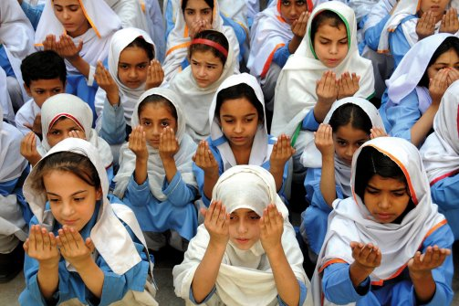
“For one Malala shot and silenced, there are now thousands of younger Malalas who cannot be kept quiet,” says former British Prime Minister Gordon Brown. (Arshad Arbab / EPA-Landov)

At the time [2009], the Taliban had swept through Swat, banning girls’ education and attacking hundreds of schools in the province. …

In order to operate, the Taliban need the acceptance—or submission—of the population. …
Instead of being chastised by the popular outrage both in Pakistan and in the West, the Taliban has responded by threatening local journalists who have covered the attack on Malala. …
Malala’s English teacher, who is close to the family, clicks his tongue when asked if he believes the attackers will get caught and punished. “I don’t think so at all,” he says. “When have they ever?”
There is talk now in Pakistan of further military sweeps of militant strongholds. But it is clear that the solution cannot be purely military. The government must address the root causes of terrorism as Malala argued. “If the new generation is not given pens, they will be given guns by the terrorists,” she said before she was shot. “We must raise our voice.”

